Advanced Python Setup Instructions

**Technical Requirements**

**Operating System Options**

* Windows XP Service Pack 2
* Windows Vista
* Windows 7
* Windows 8, Windows 8 Pro, Windows 8 Enterprise
* Windows 8.1, Windows 8.1 Pro, Windows 8.1 Enterprise
* Windows 8 RT and Windows 8.1 RT **IS NOT** supported for instructor-led online classes
* Windows 10
* Mac OS X
* **NOTE**: If you are taking an Online Instructor Led course, dual monitors are helpful but NOT required.

**OpenWeatherMap API**

In this course, you'll learn to access APIs with Python. We'll demonstrate this with the OpenWeatherMap API. It is free, but it requires an API key, which you should get before class by signing up at <http://home.openweathermap.org/users/sign_up>. After signing up, you should see an API key. Save that key somewhere where you can access it during class.

**Anaconda**

Our Advanced Python course requires Anaconda, a free Python distribution that includes many commonly used Python packages. Follow the instructions below to install Anaconda.

1. Go to the [Anaconda download page](http://continuum.io/downloads).
2. Click on the link showing your operating system and download the PYTHON 3.5 Graphical Installer. **Be sure to get Python 3.4 and not Python 2.7 (unless your company is taking a private Python 2 class)!**
3. Follow the installation instructions.
4. Test your installation by opening a command prompt and entering the following:

cd \

mkdir Webucator

cd Webucator

ipython notebook

This should open a page in your browser with a **jupyter** logo in the upper left and a file listing on the page.

1. Click New > Python 3 to start a new notebook:  
   [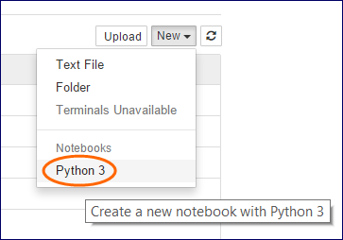](https://www.webucator.com/portal/wiki/index.cfm/Special.Files.ipython_notebook_new.png)
2. A new browser tab should open with a new untitled notebook:   
   [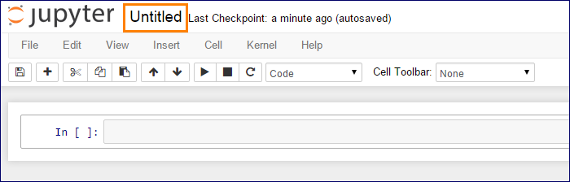](https://www.webucator.com/portal/wiki/index.cfm/Special.Files.ipython_notebook_new_nb.png)
3. Click on **Untitled** to pop up a Rename Notebook prompt. Name your new notebook "Temp":  
   [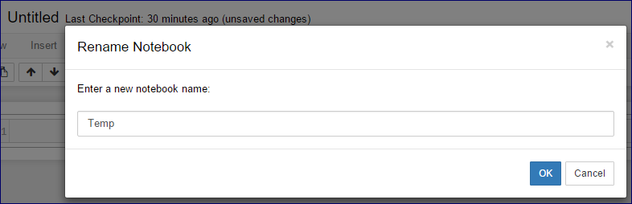](https://www.webucator.com/portal/wiki/index.cfm/Special.Files.ip_temp.png)
4. Enter %load http://bit.ly/pyt211-py in the first cell:  
   [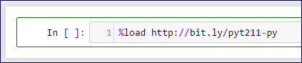](https://www.webucator.com/portal/wiki/index.cfm/Special.Files.load_pyt211.png)
5. Press Ctrl+Enter to load a script:  
   [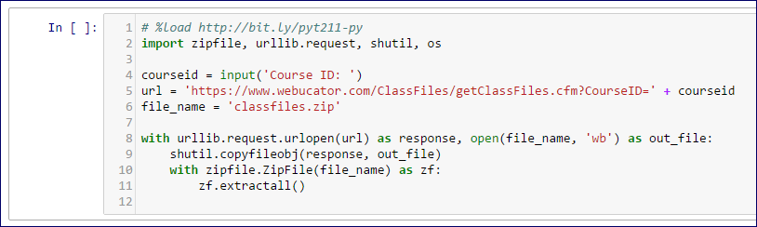](https://www.webucator.com/portal/wiki/index.cfm/Special.Files.loaded_pyt211.png)
6. Press Ctrl+Enter again to run the script. You will be prompted to enter a Course ID, which is most likely **PYT211**. *If you are setting up for an private onsite class, please confirm the Course ID with your Webucator contact.*' Enter the ID and press Enter.
7. Once the files are downloaded and unzipped, which may take a minute, the number 1 or number 2 will appear in the square brackets to the left of cell 1:  
   [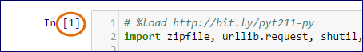](https://www.webucator.com/portal/wiki/index.cfm/Special.Files.ip_cell_1_run.png)
8. Close this tab and return to your IPython Notebook Home tab. It should include the ClassFiles folder. If it doesn't, you may need to refresh the listing:  
   [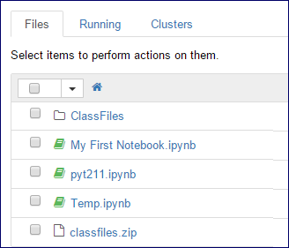](https://www.webucator.com/portal/wiki/index.cfm/Special.Files.ip_home_listing.png)
9. You're all set for class.